**SCHOOL: REDEEMER’S NURSERY AND PRIMARY SCHOOl**

JOSEPH’S SEED FESTAC TOWN

SECOND TERM EXAMINATION 2023/2024 SESSION.

CLASS: NUSERY TWO

SUBJECT: C.

* + 1. A big fat hen
    2. A red cat
    3. 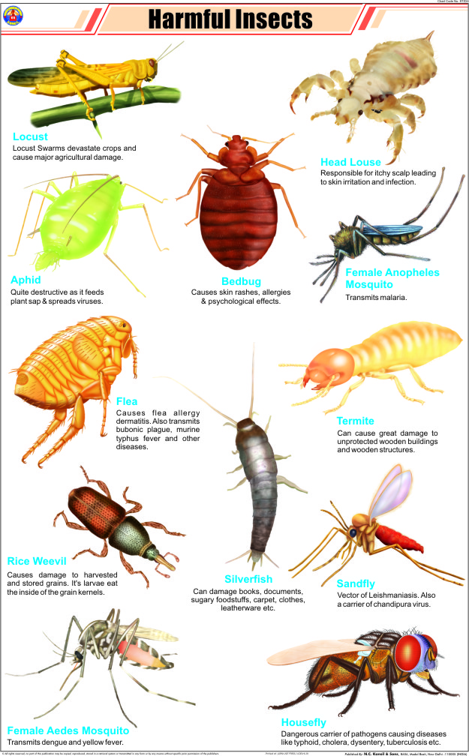My fat cap

REDEEMER’S NUERSARY AND PRIMARY SCOOL

TEACHERS DUTY ROASTER

|  |  |  |  |  |  |  |  |
| --- | --- | --- | --- | --- | --- | --- | --- |
| WEEKS | DATES |  | TEACHERS ON DUTY | |  | TOPICS | BIBLES VERSE |
| 1 | Jan .8th-12th2024 |  | ALL STAFF | |  | THANK GIVING | PSALM 100;4 |
|  |  |  |  | |  |  |  |
| 2 | Jan15th-19 2024 |  | Mrs Solomon/mrs Oyelami | |  | HUMBLE | James4;10 |
|  |  |
|  |  |
|  |  |  |  |  | |  |  |
|  |  |  |  |  | |  |  |
|  |  |  |  |  | |  |  |
|  |  |  |  |  | |  |  |
|  |  |  |  |  | |  |  |

Mention five harmful insects